

The University of Hull/CSC PhD Scholarship Scheme

26 October 2010

To whom may concern

Dear colleague

As you may know, the University of Hull (UoH) signed a MoU with the China Scholarship Council (CSC) in May 2008, setting up 10 full tuition fees scholarships each year for selected Chinese students who will enrol in a designated PhD programme at UoH with CSC PhD scholarships. The scheme was expected to last for three years in the first instance, with 2011 as the last intake.

Priority areas
CSC and UoH will support the following areas of study with priority:

Computer Science and Information Technology
Environmental Science and Technology
Biological Science
Medicine and Health
Chemistry
Nanotechnology
Sport and Exercise Science
Electrical and Electronic Engineering
Humanities
Social Sciences
Business
Logistics and Supply Chain Management
Law
Music and Music Technology

How to apply
Contributed to CSC PhD Scholarships, the University of Hull/CSC PhD Scholarship should be open to applicants from China. However, priority should be given to UoH's partner universities by invitations. We are pleased to invite your University to nominate one outstanding PhD candidate to apply to study PhD programmes at UoH in the above areas in September 2011. Please forward the following electronic copies of candidate’s full application documents to our Xiamen Office (xfang@hullchina.com) by first week of January 2011, if possible:

- Completed Chinese & English Enquiry form (see attached 'Enquiry form')
- Completed Postgraduate Application Form (see attached 'postgrad_appform')
- Research Proposal (see attached sample: 'Developing Proposal' a & b)
- Two references
- Original copy of Degree certificate(s)
- Original copy of transcript(s)
- Original copy of IELTS/TOEFL results (In general, we require IELTS 6.0 (not lower than 5.0 for each element) or TOEFL 79 for internet test, and IELTS 6.5 for Law or language related programmes)

Please invite applicants to visit University’s website to find out more details about academic research areas or to contact relevant academics to develop/discuss research proposals.

Please note that we do not accept individual application directly sent by students. However, we accept electronic copies of full application documents double checked and sent officially by International Cooperation and Exchange Offices or Graduate Schools from Chinese partner universities.

Due to limited number of scholarships, applications might be close as soon as we receive targeted number of PhD applications from partner universities.

Please feel free to contact our Xiamen Office (tel: 0592 2191980, e-mail: xfang@hullchina.com, http://hullchina.com) if you have any further question.

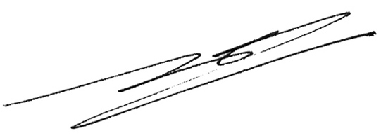
Kind regards

Dr Xiao Fang
Assistant Registrar
Assistant Director
International Office
The University of Hull

Dr Xiao Fang
Assistant Registrar
Assistant Director
International Office
University of Hull
Hull HU6 7RX
UK
Website: http://www.hull.ac.uk
Contact in China:
E-mail: xfang@hullchina.com
Website: http://www.hullchina.com
Tel/fax: 0592 2191980

